Create the Amazon RDS MySQL Instance
Provision the managed database within your isolated database subnets.
- Open the AWS RDS Console.
- Click Create database and select Full Configuration with MySQL.
- Choose the version specified in your DB.md (or the latest stable MySQL 8.0/8.4).
- Under Deployment options, pick your required availability strategy (Multi-AZ for production or Single DB instance for dev/testing and minimum 2 subnet).
- In Connectivity:
  - Select target VPC.
  - Choose or create a DB Subnet Group that includes only your Private Database Subnets.
  - Set Public access to No.
  - Create or choose a Database Security Group that allows Inbound TCP on Port 3306 only from the Security Group attached to your Application Tier EC2 instances.
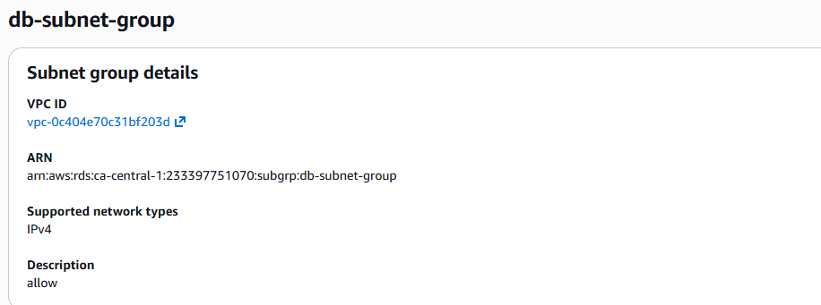
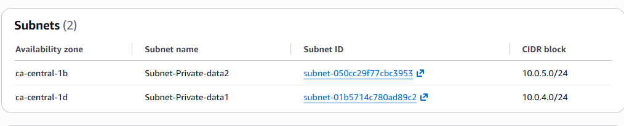
Configure Database Credentials & Settings
During the RDS setup wizard, configure your master identity records:
- DB Instance Identifier: e.g., my-app-db
- Master Username: Choose an administrative username (e.g., admin).
- Master Password: Generate a secure string (avoid special characters that break terminal strings like @ or :).
- Initial Database Name: Expand Additional Configuration at the bottom and specify an initial database name (e.g., database-1) as called out in your repository setup notes
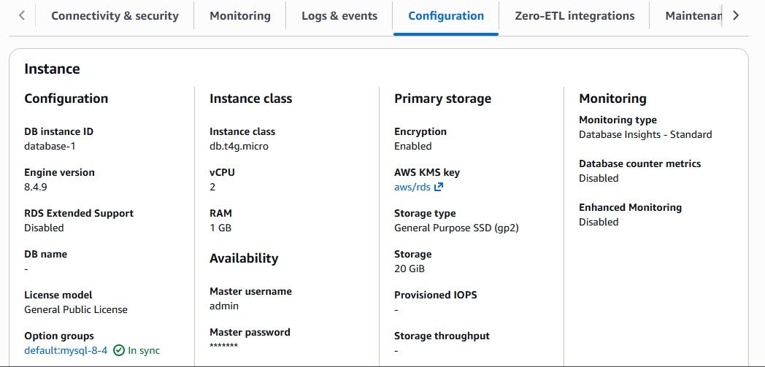
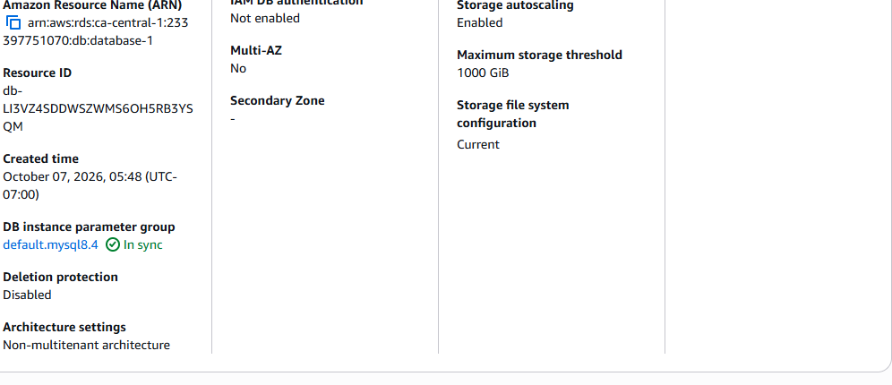
Connect to the DB from the App EC2 Terminal
Log back into private Application Tier EC2 instance via Jump server. must install a MySQL client.
From the private EC2 instance, connect to the MySQL database:
mysql -h <RDS-ENDPOINT> -u admin -p
Inside the MySQL shell, create the application database:
CREATE DATABASE feedbackdb;
Select the database:
USE feedbackdb;
Create the table to store customer feedback:
CREATE TABLE feedback (
id INT AUTO_INCREMENT PRIMARY KEY,
name VARCHAR(100),
email VARCHAR(100),
feedback TEXT,
created TIMESTAMP DEFAULT CURRENT_TIMESTAMP
);
Check that the table has been created successfully:
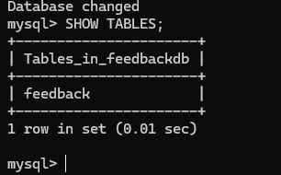
View the table structure:
DESCRIBE feedback;
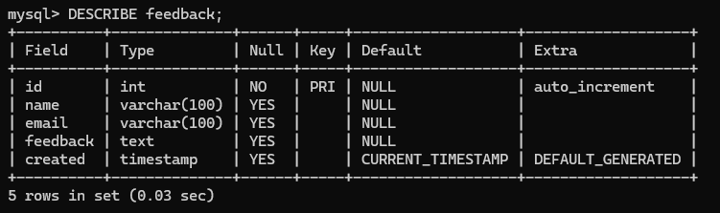
Restart the Flask Application
**Before restart flask application need to add db. endpoint name and login credential**
Stop the currently running Flask application:
pkill -f "python3 app.py"
Start the application again:
python3 ~/app.py &

Test Database Connectivity
Send a test request to the Flask API:
curl -X POST http://localhost:5000/submit \
-H "Content-Type: application/json" \
-d '{
"name":"Test",
"email":"t@t.com",
"feedback":"Hello RDS!"
}'
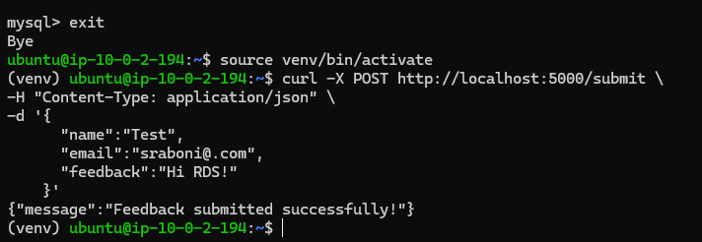
For verify output go to db terminal
USE feedbackdb;
View the stored feedback:
SELECT * FROM feedback;
